**DAILY ONLINE ACTIVITIES SUMMARY**

|  |  |  |  |  |  |  |  |
| --- | --- | --- | --- | --- | --- | --- | --- |
| **Date:** | 03/06/2020 | | | | **Name:** | AMBIKA V | |
| **Sem & Sec** | 4th Sem Section 'A' | | | | **USN:** | 4AL18CS005 | |
| **Online Test Summary** | | | | | | | |
| **Subject** | | **Object oriented concepts** | | | | | |
| **Max. Marks** | | **30** | | **Score** | | **17** | |
| **Certification Course Summary** | | | | | | | |
| **Course** | **Introduction to java programming** | | | | | | |
| **Certificate Provider** | | | **greatlearning academy** | **Duration** | | | **3.5 hours** |
| **Coding Challenges** | | | | | | | |
| **Problem statement 1:**Write a code segment in java to swap two numbers using call by object reference.  **Problem statement 2:**Write a Java program to find Last Digit of a^b (a to the power b) for Large Numbers. | | | | | | | |
| **Status: completed** | | | | | | | |
| **Uploaded the report in Github** | | | | **yes** | | | |
| **If yes Repository name** | | | | **https://github.com/ambika0202/lockdown-coding-** | | | |
| **Uploaded the report in slack** | | | | **yes** | | | |

**ONLINE TEST DETAILS:**  OOC test was scheduled from 09:15 am to 10:00am .The portion for the IA was 2nd and 3rd module there were 30 questions and the time assigned was 40 minutes the questions were mcq type.

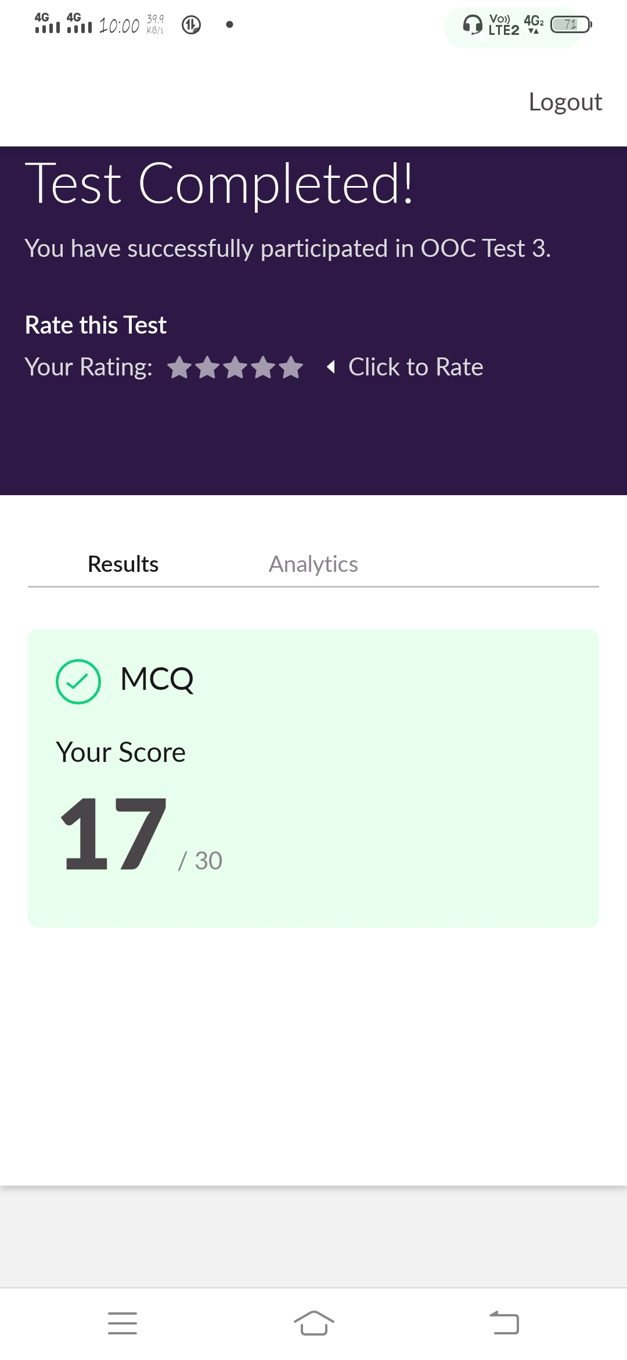

**CERTIFICATION COURSE DETAILS:**

Today I studied about collections in java.The Collection in Java is a framework that provides an architecture to store and manipulate the group of objects.Java Collection framework provides many interfaces (Set, List, Queue, Deque) and classes (ArrayList, Vector, LinkedList, PriorityQueue, HashSet, LinkedHashSet, TreeSe

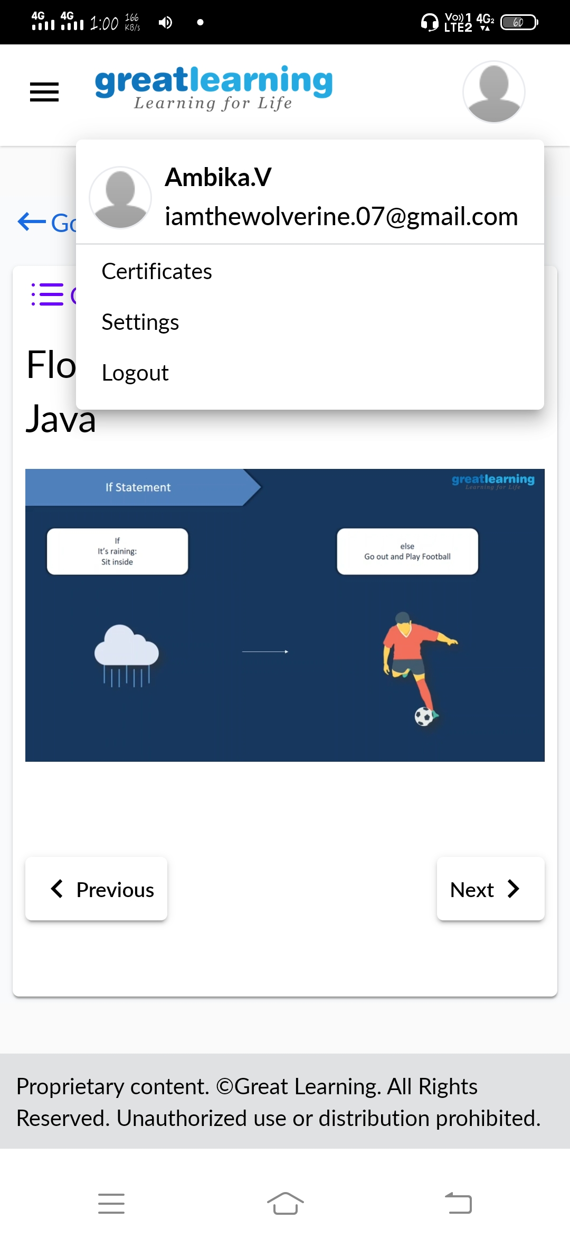

**CODING CHALLENGES DETAILS**:

**Problem statement 1:** Write a code segment in java to swap two numbers using call by object reference.

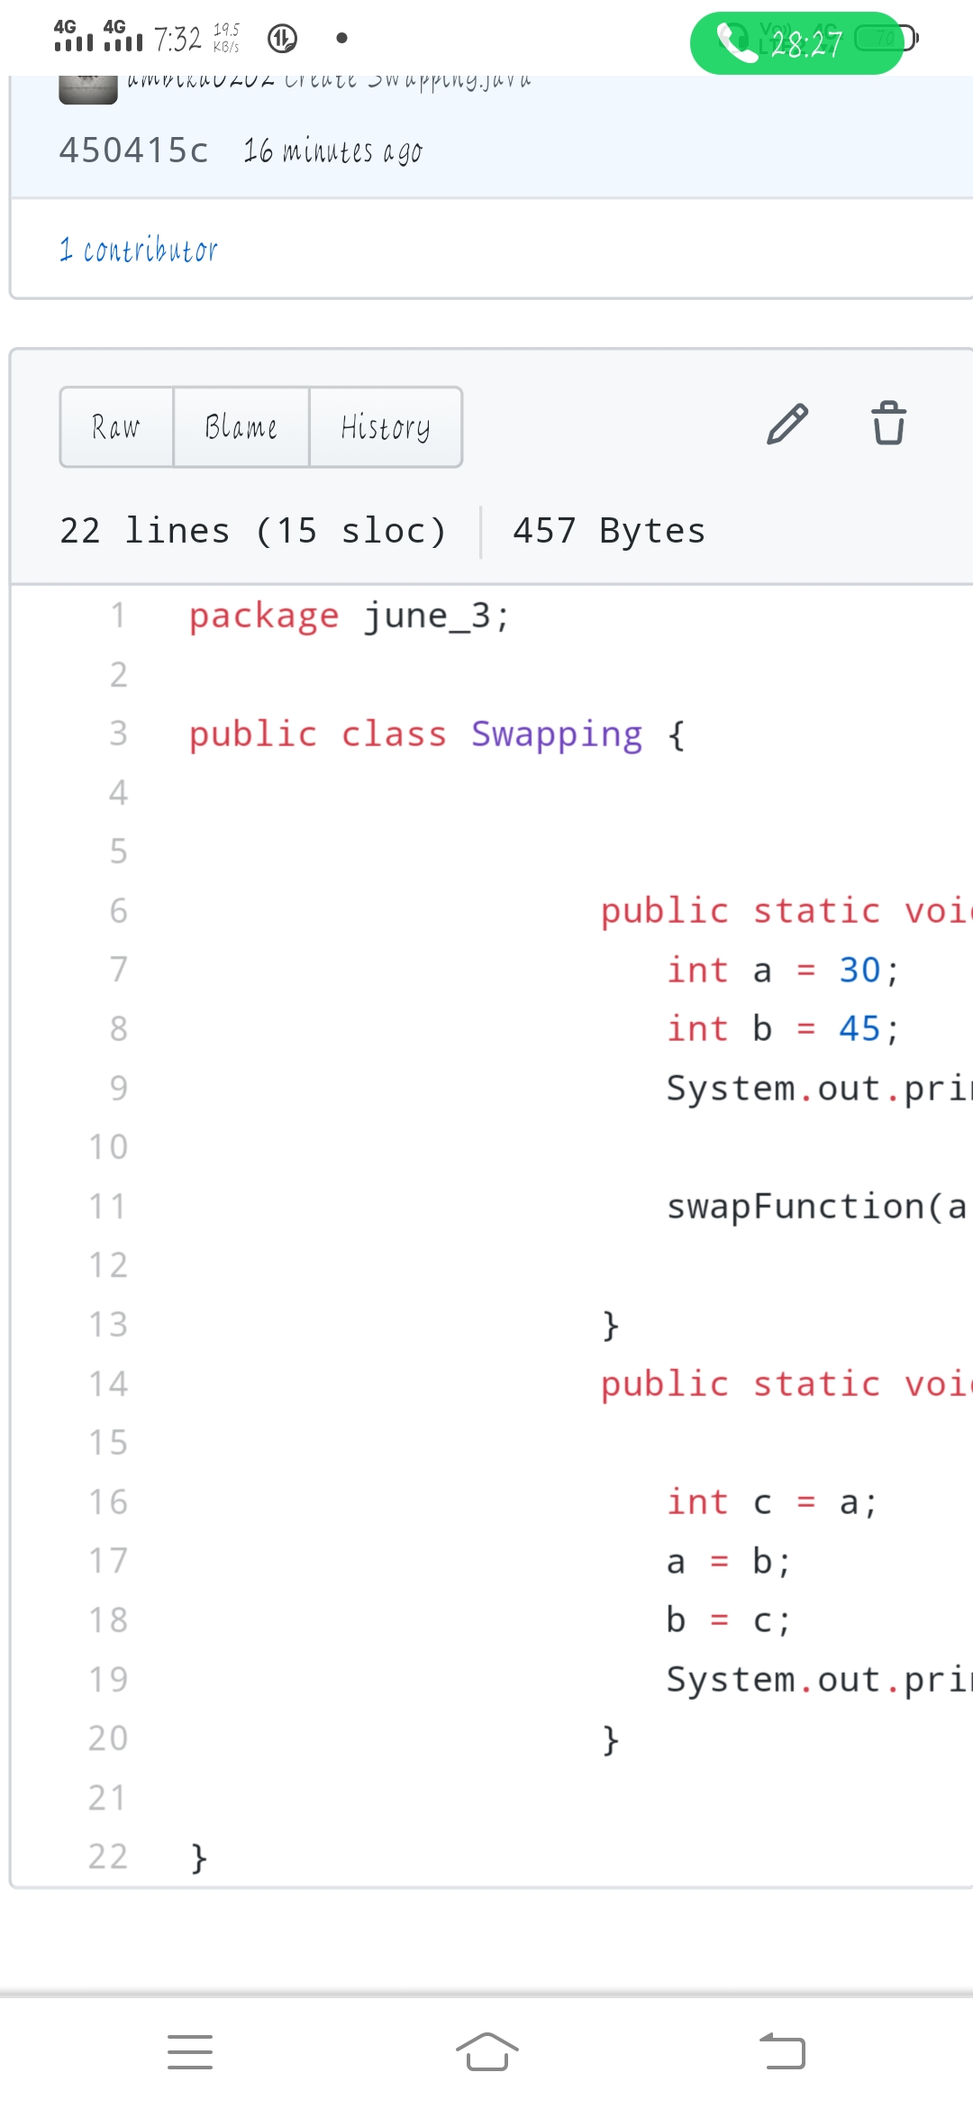

**Problem statement 2 :** Write a Java program to find Last Digit of a^b (a to the power b) for Large Numbers.

